ReactJS Hands-on 13 - Blogger App (Conditional Rendering & Lists)

Commands Used
- npx create-react-app bloggerapp
- cd bloggerapp
- npm start

Project Structure

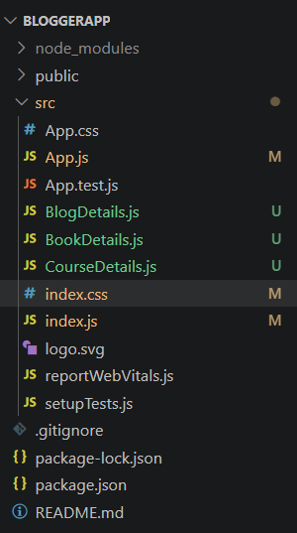

App.js
import React from "react";
import BookDetails from "./BookDetails";
import BlogDetails from "./BlogDetails";
import CourseDetails from "./CourseDetails";
import "./index.css";
function App(){
const books=[{id:101,bname:"Master React",price:670},{id:102,bname:"Deep Dive into Angular 11",price:800},{id:103,bname:"Mongo Essentials",price:450}];
const blogs=[{id:1,title:"React Learning",author:"Stephen Biz",description:"Welcome to learning React!"},{id:2,title:"Installation",author:"Schwedenier",description:"You can install React from npm."}];
const courses=[{id:1,cname:"Angular",date:"4/5/2021"},{id:2,cname:"React",date:"6/3/2021"}];
return(<div className="container"><CourseDetails courses={courses}/><BookDetails books={books}/><BlogDetails blogs={blogs}/></div>);
}
export default App;

BookDetails.js
import React from "react";
export default function BookDetails(props){return(<div className="box"><h1>Book Details</h1>{props.books.map(book=><div key={book.id}><h3>{book.bname}</h3><h4>{book.price}</h4></div>)}</div>);}

BlogDetails.js
import React from "react";
export default function BlogDetails(props){return(<div className="box"><h1>Blog Details</h1>{props.blogs.map(blog=><div key={blog.id}><h3>{blog.title}</h3><h5>{blog.author}</h5><p>{blog.description}</p></div>)}</div>);}

CourseDetails.js
import React from "react";
export default function CourseDetails(props){return(<div className="box"><h1>Course Details</h1>{props.courses.map(course=><div key={course.id}><h3>{course.cname}</h3><h4>{course.date}</h4></div>)}</div>);}

index.js
import React from "react";
import ReactDOM from "react-dom/client";
import "./index.css";
import App from "./App";
const root=ReactDOM.createRoot(document.getElementById("root"));
root.render(<React.StrictMode><App/></React.StrictMode>);

index.css
body{font-family:Arial;margin:40px;}
.container{display:flex;justify-content:space-around;align-items:flex-start;}
.box{width:300px;padding:20px;border-left:4px solid green;}

Output
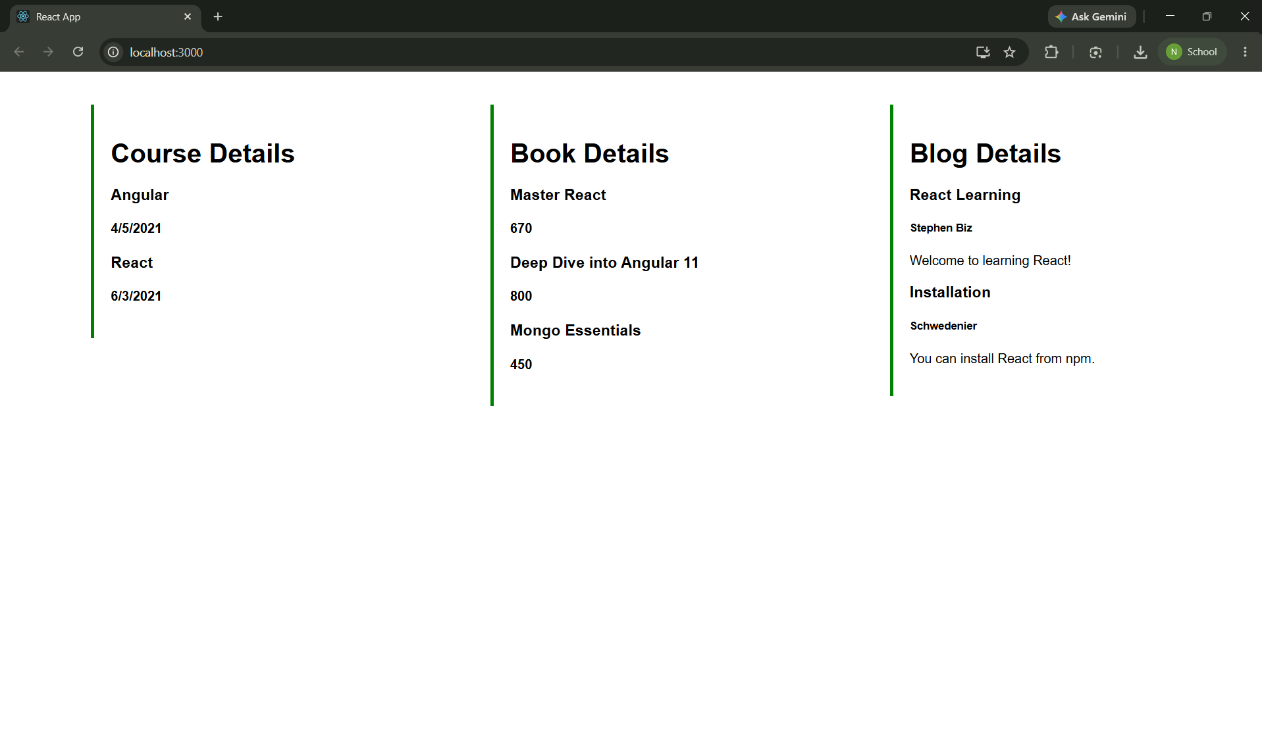

Conclusion
The Blogger App successfully demonstrates conditional rendering, rendering multiple components, lists, keys and the map() function.

